**Solution Template 2 - IAM and EC2**

Due: Saturday, Sept 22 11:59PM

**Name:**

**Problem 1: IAM (Points: 40)**

**1.1. (Points: 15 out of 50).**   
On the main IAM screen in AWS Console review your Security Status section. Paste the screenshot of the main IAM page that shows your name at the top right corner and the all green check marks next to each security recommendation.

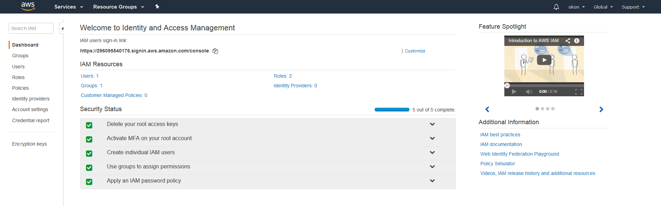

**1.2 (Points: 15 out of 50).**

To check that your new non-root access works in Admin mode (it should have access to any services) list your existing alarms by running the following command:

|  |
| --- |
| aws cloudwatch describe-alarms |

Paste the screenshot of the response below:

|  |
| --- |
|  |

**1.3. (Points: 10 out of 50).**

Create a role, with AWS Service as your trusted entity, to be used by for your EC2 instance that allows you to ONLY list your SNS topics and list your IAM roles.

Paste the screenshot of the Summary page of the created role with Permissions tab bellow:

|  |
| --- |
|  |

**Problem 2: EC2 (Points: 60)**

**2.1. (Points: 15 out of 60)**

Create an EC2 from an Amazon linux image with the role created in step 1.3.  
Paste the screenshot of your instance’s Description tab from AWS Console below:

|  |
| --- |
|  |

**2.2. (Points: 15 out of 60):** Setup SSH connection from your local computer to the created EC2 instance. Follow the instruction that AWS Console provides when you click on Connect button for your EC2 instance. Once you are logged in to your EC2, llist your SNS topics and IAM users:

|  |
| --- |
| aws sns list-topics  aws iam list-users |

Paste the screenshot with both outputs below:

|  |
| --- |
|  |

**2.3. (Points: 15 out of 60):** On your EC2 instance, install the Apache web server and start it.

Check status of the Apache Server:

|  |
| --- |
| systemctl status httpd |

Paste the screenshot of the output here:

|  |
| --- |
| Used ‘sudo service httpd status’ instead, per instructions machine doesn’t have systemctl |

**2.4. (Points: 15 out of 60):**

Create a simple html page with a small bio of yourself (your picture, and a short “about me” statement) put it into the default web directory on your EC2 instance.

You should be able to access your html page from any web browser using the the url:

http://<your-ec2-public-dns>/<your-html-file>

Example:

<http://ec2-54-175-187-246.compute-1.amazonaws.com/index.html>

Paste the URL to your page below:

<http://ec2-54-89-68-143.compute-1.amazonaws.com/index.html>

____________________________________________________________________________

**BONUS. Problem 3. (Points: 10)**

Provide an EC2 Advanced Options script which will:

* execute operating system updates
* install and launch apache web server

<https://docs.aws.amazon.com/AWSEC2/latest/UserGuide/user-data.html>

Paste your script here:

#!/bin/bash

yum update -y

yum install -y httpd

service httpd start

**on amazon linux 2:**

#!/bin/bash

yum update -y

yum install -y httpd

systemctl start httpd

____________________________________________________________________________